**Exp 4**

**AIM:- To create an interactive Form using form widget**

**Code:-**

**signup_screen.dart**

import 'package:flutter/material.dart';  
import 'expenses_screen.dart';  
import 'login_screen.dart';  
  
class SignupScreen extends StatefulWidget {  
 @override  
 _SignupScreenState createState() => _SignupScreenState();  
}  
  
class _SignupScreenState extends State<SignupScreen> {  
 final _formKey = GlobalKey<FormState>();  
 final _emailController = TextEditingController();  
 final _passwordController = TextEditingController();  
 final _confirmPasswordController = TextEditingController();  
 String _errorMessage = '';  
  
 void _signup() {  
 if (_formKey.currentState!.validate()) {  
 if (_passwordController.text != _confirmPasswordController.text) {  
 setState(() {  
 _errorMessage = 'Passwords do not match';  
 });  
 return;  
 }  
  
 // Simulate successful signup  
 Navigator.*pushReplacement*(  
 context,  
 MaterialPageRoute(builder: (context) => ExpensesScreen()),  
 );  
 }  
 }  
  
 @override  
 Widget build(BuildContext context) {  
 return Scaffold(  
 appBar: AppBar(title: Text('Sign Up', style: TextStyle(fontWeight: FontWeight.*bold*))),  
 body: Padding(  
 padding: EdgeInsets.all(16.0),  
 child: Form(  
 key: _formKey,  
 child: Column(  
 children: [  
 TextFormField(  
 controller: _emailController,  
 decoration: InputDecoration(  
 labelText: 'Email',  
 prefixIcon: Icon(Icons.*email*),  
 ),  
 validator: (value) => value!.isEmpty ? 'Enter email' : null,  
 ),  
 SizedBox(height: 16),  
 TextFormField(  
 controller: _passwordController,  
 obscureText: true,  
 decoration: InputDecoration(  
 labelText: 'Password',  
 prefixIcon: Icon(Icons.*lock*),  
 ),  
 validator: (value) => value!.length < 6 ? 'Min 6 chars' : null,  
 ),  
 SizedBox(height: 16),  
 TextFormField(  
 controller: _confirmPasswordController,  
 obscureText: true,  
 decoration: InputDecoration(  
 labelText: 'Confirm Password',  
 prefixIcon: Icon(Icons.*lock_outline*),  
 ),  
 validator: (value) => value!.isEmpty ? 'Confirm password' : null,  
 ),  
 SizedBox(height: 16),  
 if (_errorMessage.isNotEmpty)  
 Text(_errorMessage, style: TextStyle(color: Colors.*red*, fontWeight: FontWeight.*bold*)),  
 SizedBox(height: 16),  
 ElevatedButton(  
 onPressed: _signup,  
 child: Text('Sign Up', style: TextStyle(fontWeight: FontWeight.*bold*)),  
 ),  
 SizedBox(height: 16),  
 Row(  
 children: [  
 Expanded(child: Divider(thickness: 1)),  
 Padding(  
 padding: EdgeInsets.symmetric(horizontal: 8.0),  
 child: Text('OR', style: TextStyle(fontWeight: FontWeight.*bold*)),  
 ),  
 Expanded(child: Divider(thickness: 1)),  
 ],  
 ),  
 SizedBox(height: 16),  
 ElevatedButton.icon(  
 onPressed: () {},  
 icon: Icon(Icons.*phone*),  
 label: Text('Sign up with Phone'),  
 ),  
 SizedBox(height: 16),  
 ElevatedButton.icon(  
 onPressed: () {},  
 icon: Icon(Icons.*g_mobiledata*),  
 label: Text('Sign up with Google'),  
 ),  
 SizedBox(height: 16),  
 ElevatedButton.icon(  
 onPressed: () {},  
 icon: Icon(Icons.*apple*),  
 label: Text('Sign up with Apple'),  
 ),  
 SizedBox(height: 16),  
 GestureDetector(  
 onTap: () {  
 Navigator.*pushReplacement*(  
 context,  
 MaterialPageRoute(builder: (context) => LoginScreen()),  
 );  
 },  
 child: Text(  
 'Already registered? Login',  
 style: TextStyle(fontSize: 16, fontWeight: FontWeight.*bold*, color: Colors.*blue*),  
 ),  
 ),  
 ],  
 ),  
 ),  
 ),  
 );  
 }  
}

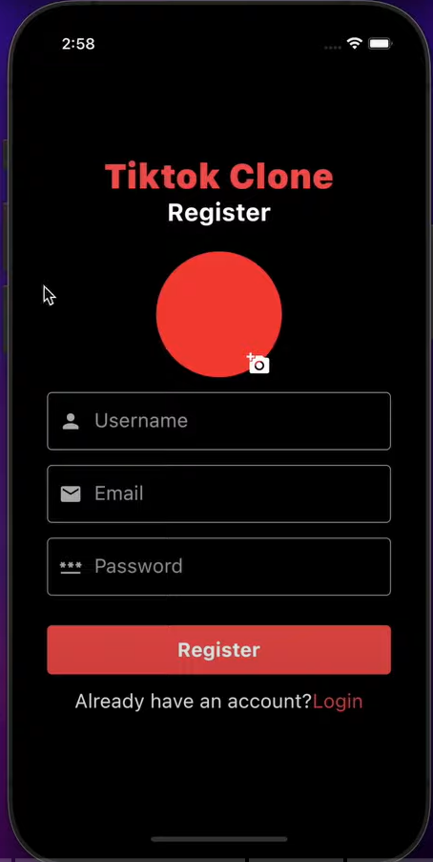

**login_screen:-**

import 'package:flutter/material.dart';  
import 'expenses_screen.dart';  
import 'signup_screen.dart';  
  
class LoginScreen extends StatefulWidget {  
 @override  
 _LoginScreenState createState() => _LoginScreenState();  
}  
  
class _LoginScreenState extends State<LoginScreen> {  
 final _formKey = GlobalKey<FormState>();  
 final _emailController = TextEditingController();  
 final _passwordController = TextEditingController();  
 String _errorMessage = '';  
  
 void _login() {  
 if (_formKey.currentState!.validate()) {  
 // Simulate successful login  
 Navigator.*pushReplacement*(  
 context,  
 MaterialPageRoute(builder: (context) => ExpensesScreen()),  
 );  
 }  
 }  
  
 @override  
 Widget build(BuildContext context) {  
 return Scaffold(  
 appBar: AppBar(title: Text('Login', style: TextStyle(fontWeight: FontWeight.*bold*))),  
 body: Padding(  
 padding: EdgeInsets.all(16.0),  
 child: Form(  
 key: _formKey,  
 child: Column(  
 children: [  
 TextFormField(  
 controller: _emailController,  
 decoration: InputDecoration(  
 labelText: 'Email',  
 prefixIcon: Icon(Icons.*email*),  
 ),  
 validator: (value) => value!.isEmpty ? 'Enter email' : null,  
 ),  
 SizedBox(height: 16),  
 TextFormField(  
 controller: _passwordController,  
 obscureText: true,  
 decoration: InputDecoration(  
 labelText: 'Password',  
 prefixIcon: Icon(Icons.*lock*),  
 ),  
 validator: (value) => value!.length < 6 ? 'Min 6 chars' : null,  
 ),  
 SizedBox(height: 16),  
 if (_errorMessage.isNotEmpty)  
 Text(_errorMessage, style: TextStyle(color: Colors.*red*, fontWeight: FontWeight.*bold*)),  
 SizedBox(height: 16),  
 ElevatedButton(  
 onPressed: _login,  
 child: Text('Login', style: TextStyle(fontWeight: FontWeight.*bold*)),  
 ),  
 SizedBox(height: 16),  
 Row(  
 children: [  
 Expanded(child: Divider(thickness: 1)),  
 Padding(  
 padding: EdgeInsets.symmetric(horizontal: 8.0),  
 child: Text('OR', style: TextStyle(fontWeight: FontWeight.*bold*)),  
 ),  
 Expanded(child: Divider(thickness: 1)),  
 ],  
 ),  
 SizedBox(height: 16),  
 ElevatedButton.icon(  
 onPressed: () {},  
 icon: Icon(Icons.*phone*),  
 label: Text('Login with Phone'),  
 ),  
 SizedBox(height: 16),  
 ElevatedButton.icon(  
 onPressed: () {},  
 icon: Icon(Icons.*g_mobiledata*),  
 label: Text('Login with Google'),  
 ),  
 SizedBox(height: 16),  
 ElevatedButton.icon(  
 onPressed: () {},  
 icon: Icon(Icons.*apple*),  
 label: Text('Login with Apple'),  
 ),  
 SizedBox(height: 16),  
 GestureDetector(  
 onTap: () {  
 Navigator.*pushReplacement*(  
 context,  
 MaterialPageRoute(builder: (context) => SignupScreen()),  
 );  
 },  
 child: Text(  
 'Don’t have an account? Sign Up',  
 style: TextStyle(fontSize: 16, fontWeight: FontWeight.*bold*, color: Colors.*blue*),  
 ),  
 ),  
 ],  
 ),  
 ),  
 ),  
 );  
 }  
}

